Practical No. 4

Name : Danish Altaf Solkar Class : CO - B
Enrolment no. : 24111590805 Batch : 2

Aim : Write C/ Python program to calculate Average Waiting Time and Turnaround Time of processes with First Come First Serve (FCFS) CPU Scheduling Algorithm

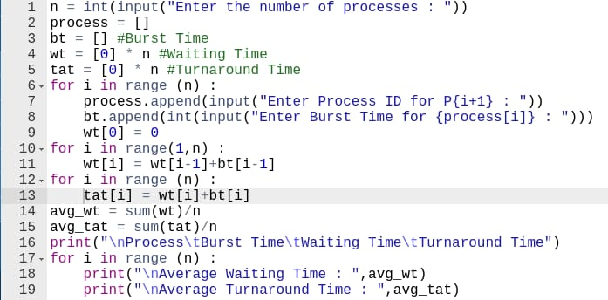

Output :-

